TRY OUT MODUL LINUX ENVIRONMENT

IT NETWORK SYSTEMS ADMINISTRATION

Login
Username: root/user
Password: P@ssw0rd123

System Configuration
Timezone: Europe/Paris

General Configuration
Fully Qualified Domain Name | Ipv4 | Services
fw.smkn22.id | internet: 100.100.100.100/24  int-zone: 192.168.10.10/24 dmz-zone: 172.16.10.10/24 | Firewall(nftables), VPN  Server(WireGuard)
int-srv.smkn22.id | int-zone: 192.168.10.254/24 | DNS Server(Bind9), LDAP  Directory(slapd), Certificate  Authority(OpenSSL)
mail-srv.smkn22.id | dmz-zone: 172.16.10.251/24 | Mail Server (Postfix(SMTP),  Dovecot(IMAP)), Webmail(Roundcube), Mailclient (Thunderbird)
web-01.smkn22.id | dmz-zone: 172.16.10.252/24 | Virtual IP(keepalived), HAProxy, Web  Server
web-02.smkn22.id | dmz-zone: 172.16.10.253/24 | Virtual IP(Keepalived), Load  Balancer(Haproxy), Web Server(Nginx)
ani-clt.smkn22.id | internet: 100.100.100.200/32 | Client

NAME | NETWORK
int-zone | 192.168.10.0/24
dmz-zone | 172.16.10.0/24
internet | 100.100.100.0/24
vpn | 10.10.10.0/24

Topology
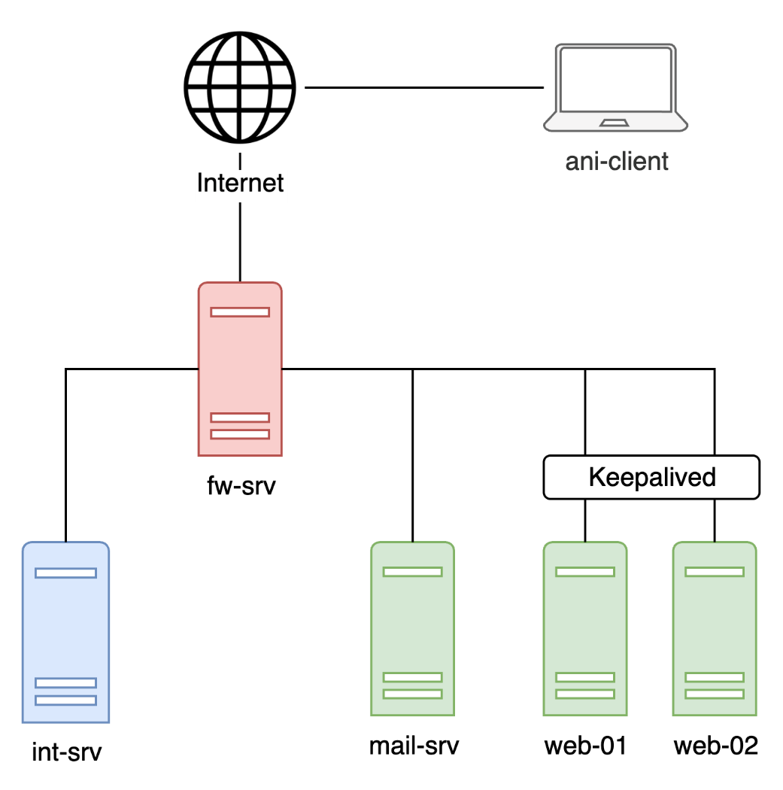

Part 1 INT (Internal)
Int-srv.smkn22.id

DNS
Set up a DNS server using BIND9 to manage domain names.
- Install & Configure BIND9
- Create DNS Zones
  - Create a forward zone for: smkn22.id
  - Create a reverse zone for the int-zone and dmz-zone
- Add DNS Records
  - Add forward and reverse records for all servers listed in the general configuration.
  - Add additional records on the table.
Type | Name | Value/Target
A | www | 100.100.100.100
A | mail | 172.16.10.251
A | vip | 172.16.10.200
A | vpn | 100.100.100.100
CNAME | www.int | vip.smkn22.id
MX | @ | 10 mail.smkn22.id

LDAP
Install and configure LDAP using slapd to manage user accounts. These users will be used to log in to the mail server.
- Install LDAP and use slapd
- Create LDAP users
● Create the following users in LDAP. These users will be used for email login (authentication)
Full Name | Username (uid) | Password | Organizational Unit (OU) | Email Address
Administrator | admin | P@ssw0rd | - | -
FuFuFaFa | fufufafa | P@ssw0rd | qwerty | fufufafa@smkn22.id
wowo1 wowo2  … wowo5 | wowo1 wowo2  … wowo5 | P@ssw0rd | qwerty | wowo1@smkn22.id wowo2@smkn22.id … wowo5@smkn22.id

CA
Use OpenSSL to create your own Certificate Authority (CA) and generate certificates for your server (web and mail).
1. Create Root CA
- Make a Root CA with the common name: “SMKN22-CA”
- For other fields like Country, State, etc., you can use any value
- Install SMKN22-CA on every server and client
2. Create Certificates for Servers
- Generate and sign the following certificates directly using the Root CA:
- A certificate for web server, valid for: www.smkn22.id, www.int.smkn22.id
- A certificate for mail server, valid for mail.smkn22.id
2. Save All Certificates
- Save the certificates in this folder: /opt/grading/ca
- ca.pem: Root CA certificate
- web.pem: Web server certificate
- mail.pem: Mail server certificate

Ansible
We will set up Ansible on the server int-srv and make it control server web-02. All Ansible files (settings, playbooks, and modules) must be saved in the /etc/ansible directory.
- Configure the Ansible inventory to include web-02, so you can test the connection using the following command:
ansible web-02 -m ping
- Create playbook 01-web-int.yml
  - This playbook will install Nginx
  - It will also create a virtual host that listens on port 8000
  - When you open the website, it will show the message: “Awikwok bet!”
  - Make the playbook idempotent
  - To run the playbook, use this command:
ansible-playbook /etc/ansible/01-web-int.yml

Part 2 DMZ (Demilitarized Zones)
mail-srv.smkn22.id

Mail Server
Deploy a fully functional mail server using Postfix and Dovecot to allow users to send and receive emails under the domain smkn22.id.
- Software Installation
  - Postfix - to manage sending and receiving emails SMTP.
  - Dovecot - to enable users to access and read emails via IMAP.
- Mail Server Configuration
  - Configure the server to handle mail delivery for the domain smkn22.id
  - Users should be able to read their emails using IMAP
  - Enforce TLS encryption for all connections between email clients and the server
    - If the Certificate Authority (CA) task has been completed, use the certificate issued for the mail server.
    - If not, generate a self-signed certificate.
  - Ensure clients that trust the SMKN22-CA can validate the certificate.
- LDAP Integration
  - Integrate with LDAP to authenticate users via int-srv.smkn22.id.
  - Set up Maildir directories for the following users:
    - fufufafa
○ wowo1 through wowo5
  - Ensure that the LDAP user fufufafa can
    - Login in using ther UID (username).
  - Restrict login access:
    - Only users under ou=qwerty are permitted to authenticate and use the mail server.
- Webmail Access
  - Install Roundcube using Apache2 as the web server
  - Expose the Roundcube webmail interface on:
    - https://mail.smkn22.id
- Setup e-mail fufufafa@smkn22.id in Thunderbird, and can send to other users/himself

web-01.smkn22.id & web-02.smkn22.id

HA Web
Set up a high-availability reverse proxy system using HAProxy and Keepalived on two servers: web-01 and web-02.
- Keepalived Configuration (Virtual IP)
  - Create a virtual IP (172.16.10.200/24) that will automatically move to the backup server if the main server goes down.
  - web-01: acts as the MASTER with priority 120
  - web-02: acts as the BACKUP with priority 110
- HAProxy Configuration for Load Balancing
  - Install and configure HAProxy on both servers (web-01 and web-02) to distribute traffic to two Nginx web servers:
  - web-01: 172.16.10.252:8080
  - web-02: 172.16.10.253:8080
  - All HTTP requests must be redirected to HTTPS.
  - HAProxy should perform TLS termination (HAProxy handles HTTPS and forwards to Nginx using HTTP).
  - Add an HTTP header via-proxy: hostname to responses (replace “hostname” with the proxy’s hostname) to help with troubleshooting.
  - If you already have a certificate from your CA, use the web certificate (web.pem).
  - Make sure a client that only trusts your root CA can validate the entire certificate chain.
  - If not, create a self-signed certificate.
- Web Server nginx
  - On web-01 and web-02 install nginx and listen port 8080 with index.html “Hello from ${hostname}”

Part 3 Firewall
fw.smkn22.id

nftables
Create firewall and NAT rules using nftables to control which traffic is allowed or blocked in your network.
- Allow Internet Access
  - Devices in the INT (internal) and DMZ networks can access the internet.
- NAT Masquerade
  - When sending traffic from your network to the internet (through the WAN), the firewall must replace the source IP with its own WAN IP using masquerade NAT.
- Port Forwarding
  - Forward incoming traffic from the internet to servers in the DMZ:
Port | Protocol | Forward To
80 | TCP | 172.16.10.200
443 | TCP | 172.16.10.200
53 | TCP/UDP | 192.168.10.254
- VPN Access
  - VPN clients should be able to reach both internal and DMZ networks.
- Mail Server to LDAP
  - The mail server must be allowed to query the LDAP service running on int-srv.
- Block Everything Else
  - Any other traffic that’s not mentioned above should be blocked (default deny).

Wireguard VPN
Set up WireGuard as a VPN server so that an external workstation (client) can connect securely to the internal network.
- Secure VPN Connection
- Use WireGuard to create a secure tunnel from the client to the internal network.
- All internet traffic from the client should be routed through the VPN tunnel.
- Pre-shared Key (PSK)
- For extra security, add a pre-shared key to the tunnel (used along with public/private keys).
- DNS Configuration
- The client should use the internal DNS server (not public DNS) to resolve hostnames while connected.
- IP Addressing
- Assigns VPN to the 10.10.10.0/24 subnet

- Server wg0: 10.10.10.1/24
- Client wg0: 10.10.10.2/24
- Save & Enable Configuration
- Save the WireGuard config as /etc/wireguard/wg0.conf
- Start it using: sudo wg-quick up wg0
- Enable it to run at boot (system service): sudo systemctl enable wg-quick@wg0

Part 4 Client
General Configuration
1. Create a local user named fufufafa
- Set the password to P@ssw0rd
2. Configure VPN wireguard to fw.smkn22.id
- Save the WireGuard config as:
/etc/wireguard/wg0.conf
Start it using:
sudo wg-quick up wg0
- Enable it to run at boot (system service): sudo systemctl enable wg-quick@wg0
3. Ensure access to internal web services via vpn
- Able to access https://www.smkn22.id and https://www.int.smkn22.id
4. Verify webmail access through VPN
- Access Roundcube webmail at https://mail.smkn22.id after VPN connection
- Successfully log in using the account fufufafa@smkn22.id
- Able to send an email to the same account (self-mail test) without issue

5. https://www.smkn22.id is defined as startpage, can be reached and doesn't show any certificate errors

